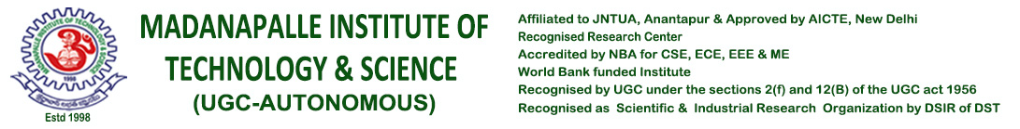

**STUDENT WELFARE CELL (Mobile No-8008570079)**

**Details:**

Name of the Student (As per SSC) :

Year / Class / Branch / Section :

Register Number :

Father Name (As per SSC) :

Mother Name (As Per SSC) :_________________________________________________________

Date of Birth (As per SSC) :

Contact Number

(Both: Parent’s & Student’s No) :

E-mail Address :

Blood Group **: _______________________________________________________**

Current Address **:___________________________________________________________**

**___________________________________________________________**

**Existing Students** (Please give √ mark in the required column(s)) **Ex-students**





1. Study / Bonafide Certificate 1. Course completion certificate





(Please write the PURPOSE below) (Enclosures: No Dues Xerox copy)

2. Course estimation form for Edu. Loan 2. Transfer Certificate (Specify If Convener Payment/Reimbursement (Enclosures: PC & No Dues Xerox copy.









/Management Quota) **\*Stamp size photo** (Hard copy) during issues.



3. New ID card 3.Original marks memos of X and Inter

* 

(Enclosures: Rs.150/- Receipt paid at (Enclosures: Original No Dues form)

Account Section and Passport size Photo)

4. Study/Bonafide for Income Tax 4. Recommendation Letter for Higher Education







(Enclosure: Original Fee Receipt. (Enclosure: Copy of the Letter with signature

(If certificate needed on Mother’s name, from either the HOD or Professor(s)

pls write Mother’s name in place of Father’s name,)

5. Others 5. Others

* 

Sir,

I request you to issue the above certificate for the purpose of

Thanking you sir,

Date: Yours faithfully,

* Please send the filled in request form with scanned copies of enclosures to [studenthelpdesk@mits.ac.in](mailto:studenthelpdesk@mits.ac.in)
* Original No Dues copy should be submitted at the SWO office for original marks memos during issues.
* Timing of issue of certificates will be informed through e-mail